Maryland Association of Student Councils
Affiliated with the National Association of Student Councils

Dear Administrators,

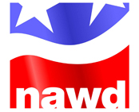
The National Conference on Student Activities (NCSA) provides an annual experience that benefits advisors and the schools in which they work. The conference, presented by the National Association of Workshop Directors, targets educators from across the US who work with middle and high school sponsored activities and who seek answers to questions such as the following: “How do I design activities that promote a safe learning environment?” “What do I need to do to ensure these activities support academic and socio-emotional learning in accordance with state and federal guidelines?” “In what way does our activity program best build connectedness within our student body so that students want to be in school and thus lower our dropout rate?” “What is the best way to promote college and career readiness in our student activities?”

In addition, advisors receive the training they need to be successful in their programs and alleviate the frequent turnover among activity advisors as well as build strong programs, which ensure that achievement will follow.

This conference provides a network of support among advisors, the rejuvenation needed by hard working advisors and the opportunity to grow their leadership knowledge base. In turn, these advisors create positive learning environments, improve school climate and culture, and create a sense of belonging at school for students and staff.

Data shows that when strong activity programs are established, achievement follows in terms of better-standardized test scores, higher grades, better attendance, a better graduation rate, and higher college admission. Well-trained advisors provide experiences that are exponentially greater. They also know how to work well with administrators to create schools that excel.

You support your activity advisors, your school, and your community by sending activity advisors to NCSA. Their attendance benefits all associated with your school community.

Thank you for considering this opportunity for your students, your school, and your community.

Respectfully,
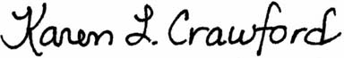

Karen L. Crawford
MASC Assistant Executive Director

Letter credit: Terry Hamm, Executive Director, Texas Association of Student Councils (TASC)

