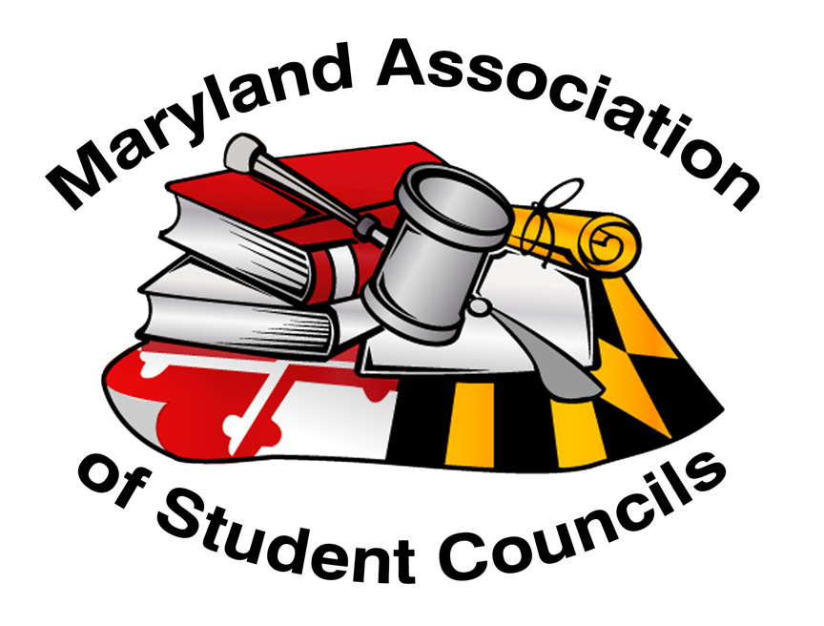
Maryland Association of Student Councils
Outstanding Activity/Project Recognition

Our students at the school and regional level spend a lot of time and talents planning and executing activities and projects for their school/regional community. Whether these are spirit, social, advocacy, or service activities, they are meaningful and worthy of recognition. All regions are encouraged to submit their best activity/project for recognition for the MASC Outstanding Activity/Project. This submission will recognize a school in the region or a regional activity/project that has made a positive impact on their school/regional community. Each region will select the activity/project to be recognized.

The activity/project to be recognized is made by each region. Schools are encouraged to contact their regional advisors/presidents to apply for this recognition. It is up to the region how the selection is made.

Submissions need to be completed no later than midnight, March 1st. If a school project is recognized, the school’s student council must be a MASC member. Schools or regions will receive a certificate for their school and recognition from MASC. All qualified entries will be posted on the MASC web as a resource for others.

In selecting the activity/project, regions should consider the following:

Recognition Criteria
- Impact of the project on the school or local community or results achieved
- Creativity of the project idea and/or its implementation
- Amount of involvement by student members
- Leadership demonstrated by group members in carrying out the project
- Written quality and clarity of the submission.

Official Guidelines
- Activity/Project must have been carried out between March 1, 2020 and March 1, 2021.
- Each region may turn in only one submission for this recognition.
- Entries must be submitted electronically.
- Attachments to elaborate on items mentioned in the application are encouraged. Additional materials can include photos, newspaper clippings, copies of printed programs, and so forth. Video clips or PowerPoint presentations to augment the submission are also accepted.

How to Submit

In order to make this a “user friendly” application, schools or regions may simply type information directly into this document (please “save as” and include the region/school in the document name).

The application document will be uploaded to the Google form.

Additional documentation will also be uploaded in the Google form.

Please refer questions to Nicete.Moodie@mdstudentcouncils.org or Karen.Crawford@mdstudentcouoncils.org

Form Submission: https://forms.gle/dW5fPFP5EiReyb6w8

Maryland Association of Student Councils

Outstanding Activity/Project Recognition

Details

- School Name & Region (just Region if a regional activity/project is submitted)
- If a school, is the school’s student council a member of MASC?
- School Advisor’s Name: (if a school activity/project)
- School Advisor’s Email: (if a school activity/project)
- Principal Name: (if a school activity/project)
- Principal Email: (if a school activity/project)
- Number of members in your group:
- Number of students/other participating in activity/project:
- Date(s) of activity/project:

- Project Summary
Name of Project:
Briefly summarize your project and its accomplishments.

- Project Objectives
Describe the need your project was designed to address - provide supporting data. What did your group hope to accomplish by sponsoring this project?

- Project Activities
Summarize the major project activities, from the planning stages through evaluation. Include descriptions of activities involved, committees formed, timeline followed, resources used, etc.

- Leadership
How did your group’s student leaders demonstrate leadership in carrying out this project? (i.e., What problems were overcome? What resources were utilized? In what ways did you collaborate with other organizations? How did student leaders motivate others to get involved?)

- Project Results
Describe the impact of the project on the school or local community. How did you determine if you achieved your objectives? (What results were observed, how were attitudes or behaviors changed, how did you know you made a difference, and so forth?)

- Presentation
Please submit video clips, pictures, Powerpoint presentations, newspaper clipping (school or community), copies of printed programs, etc. In addition, please specifically identify one photo to be used on the slide show that will be shown during the recognition at the MASC Awards Program during the Convention.

Form Submission: https://forms.gle/dW5fPFP5EiReyb6w8

