The Maryland Association of Student Councils
Appointed Staff Application 2021-2022
Application Link: https://forms.gle/FfB12GwnwK5ojYy46
Completed application deadline is 11:59 p.m., Saturday, June 12

Dear MASC Appointed Staff Applicant:

While it is always sad to say goodbye to a year of outstanding leadership and service in the Maryland Association of Student Councils (MASC), few things are more exciting than ushering in a new one. The transition to the 2021-2022 school year is a process that begins now. The MASC Executive Directors and the MASC President invites you to join MASC in this exciting new time by applying as a member of the Executive Staff.

MASC’s Mission
- Empower students to become involved in issues that directly relate to them;
- Provide a forum for students to express and exchange ideas;
- Provide effective training for students in the areas of leadership, communication, representation, and personal development;
- Communicate information to regional associations’ member schools about issues that affect students and about activities of interest that are occurring across the state;
- Represent the views of Maryland students to the Maryland State Board of Education, the Maryland General Assembly, the National Student Council, and to other organizations impacting the lives of students; and
- Familiarize students with the processes of local and state government.

Our task is a large one and we need dedicated student leaders who are interested in participating in student government at the state level and willing to work together to accomplish our goals. Being on MASC staff is an experience of immeasurable value that opens indescribable opportunity. Through the year, you can earn service-learning hours, grow and apply your leadership skills, and make friendships to last a lifetime. MASC seeks the best student leaders that our schools have to offer, and the MASC President appoints them to positions where they can excel and learn through their service.

Middle School Ambassadors
The role of the MS Ambassadors is to work directly with their respective Divisional liaison to assist with outreach to middle school students in your division.
Divisions
- 1 - Garrett, Allegany, Washington
- 2 - Frederick, Carroll, Howard
- 3 - Baltimore County, Baltimore City, Harford
- 4 - Montgomery, Prince George’s, Anne Arundel
- 5 - Charles, Calvert, St. Mary’s
- 6 - Cecil, Kent, Queen Anne’s
- 7 - Talbot, Caroline, Dorchester
- 8 -Wicomico, Worcester, Somerset

As an Middle School Ambassador you will be responsible for the following:
- Be a “deputy” to the Divisional Liaisons to relay information about middle school outreach, involvement, and more
- Occasionally meet with the middle school involvement committee (more information on this later) to learn more about the issues that are important to the middle school students of Maryland
- Represent middle schoolers in their division (see divisional map)
- Bring the middle school perspective to discussions at MASC events
- Work with the divisional liaison and communications department to ensure that advertisements are appealing to a middle school audience
- Call / email to middle school student council advisors or principals to make them aware of MASC (script templates to be provided)
- Explain what MASC is to middle schoolers and the benefits for being involved at the state level
- Attend regional meetings (general assemblies or executive board meetings) in their division when possible

Being a MASC staff member is an unforgettable and rewarding experience. Being on staff is a commitment of your time, a commitment of your best effort, and a commitment to excellence. Appointees will be assisting their division liaisons in planning events, creating presentations, and more. Please note, that while you are applying for a leadership position, a lot of leadership experience is not required. MASC provides the majority of the outreach resources, but we still want your insight and ideas! It is a challenge only for those willing to work not for themselves and towards their own ambition, but for the mission of MASC and the fulfillment of our shared responsibility as student leaders.

All candidates with completed applications will be interviewed. Interviews will take place by appointment between Sunday, June 13, through Wednesday, June 16, 2021, via video conferencing. Attendance at the virtual Staff Development Day on June 19th, 2021 is mandatory.

This application deadline is 11:59 p.m., Saturday, June 12, 2021. Applications of qualified student leaders are welcome! Thank you so much for your interest in joining this team, and we are thrilled to have the possibility of working with you this upcoming year!

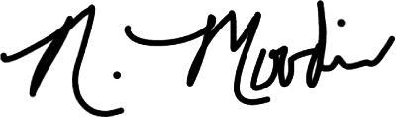
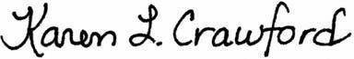
Respectfully,

Justin Peleska Nicete Moodie Karen Crawford
MASC President-Elect Executive Director Assistant Executive Director

Note: as we have difficulty recruiting students from the Eastern shore, a student from a different division could be appointed to an Eastern shore division. The main responsibility of the Middle School Ambassador is outreach to individual schools to tell them about MASC and find out how we can help their student council. The outreach part of this position can all be accomplished virtually, so if you live in Frederick County, do not think that you will need to attend an event in Wicomico County!

Criteria for Applying for Staff
MASC is a student-lead organization for students! Your willingness to serve on the Executive Staff is greatly appreciated. To apply for MASC, you must…

- Be able to fulfill the time commitment that this position holds which may include both in-person/virtual events/conferences and duties that must be fulfilled outside of these times. Understand the time commitment that this position holds by reviewing the current year’s calendar and looking at the draft calendar for the next year using this link: https://mdstudentcouncils.org/index.php/events/.
- Have attended at least one MASC event or conference such as Convention or an Executive Board meeting. It is difficult to serve in an organization if you have never attended any meeting or event for that organization!
- Be from a member school of MASC for the 2021-2022 school year. (You will have an opportunity to work with your school advisor to make sure you are from a member school.) Membership for 2021-2022 will open on July 1st.

What does being an MASC Staff Member mean?
MASC’s Executive Staff is composed of several different positions. Each position focuses on one specified area of the organization. Despite a position’s individualized duties, all staff members are expected to work together to positively impact our state. We ask that all applicants are able to make the time commitment that holding a position on MASC’s Executive Staff entails.

All Middle School Ambassador staff members shall:
- Serve under the direct supervision of the MASC 2nd Vice President
- Meet the duties and responsibilities of being an Executive Board member, including attending MASC executive board meetings and conferences when possible
- Create short reports on what you have done in your position
- Create goals and an effective action plan for what you want to accomplish
- Work cooperatively with the high school divisional liaison for your appointed division
- Abide by the MASC Code of Ethics

Application Timeline
All components of the application are due by 11:59 p.m., Saturday, June 12
- All documents will be uploaded through a Google form.
- The recommendation from an adult is also a Google form.
- No faxed or mailed applications will be accepted. Please contact an executive director if there are any issues.

Shortly after the application deadline, selected applicants will be invited to interview for a possible position. Staff interviews will take place by appointment on Sunday, June 13 through Wednesday, June 16, via video conferencing. Shortly after the conclusion of all interviews, you will be contacted with a follow-up email in regard to your application status.

Components of the Application
- Google form (includes general information, essays, interview preference times/dates, etc.)
- Information and Commitment Contract (only scan and upload the specific two pages, not the entire packet)
- ONE recommendation from an adult (specific information in the Application Packet with a link for the recommender to complete a Google form)
(Optional - a one page resume - can be uploaded in the Google form)
Information and Commitment Contract MS Ambassador (2 pages)
Type or Print NEATLY (do not use pencil!!)
These two pages will need to be scanned and uploaded to the Google form
Google Form: https://forms.gle/rpkX1vZjBRm9wgxT7

Deadline: 11:59 p.m., Saturday June 12th, 2021

Name: ________________________________________________Grade: (Fall of 2021)________
Current School: ________________________________________________Region: ___________
Personal Email address: ___________________________Cell Phone Number: ________________
(school system’s firewall block emails that are not from their system, so MASC needs a personal email)
Parent Name:________________________Cell:_______________Email:_____________________

Commitment Contract and Code of Ethics/Diversity Statement

As leaders, we must be continually aware of our actions and their effects. In order to make an impact we must exercise an awareness of responsibility to ourselves, to the organizations with which we are associated, and to other people. This code was developed through a cooperative process involving the MASC Executive Board, state officers, and regional advisors.

As leaders we will:
* Serve as role models to our peers and set an example for all to follow.
* Be inclusive of all students while advocating, involvement, and participation in various activities.
* Maintain a high level of respect towards others and ourselves.
* Strive to be committed leaders and encourage others to reach their full potential.
* Remember that part of our leadership responsibilities includes helping, training, and encouraging future leaders.
* Fulfill our role as a person whom others can count on and whose word is solid and trustworthy by refraining from cheating, stealing, or lying.
* Realize that our actions directly impact the integrity and credibility of MASC.
* Maintain the high integrity that MASC has achieved.
* Abide by all rules and procedures laid out by our host facility and organization
MASC Diversity Statement: MASC does not discriminate on the basis of race, color, religion, sex, age, ancestry or national origin, familial status, marital status, physical or mental disability, sexual orientation or genetic information in its programs and activities and provides equal access and a welcoming environment to all groups.

By signing this form, I pledge to fulfill my duties as assigned to the best of my ability, and will commit myself to attending Executive Board meetings and major MASC events as scheduled on the yearly calendar. I am committing to agree to abide by this Code of Ethics and MASC Diversity Statement.

Student Signature ______________________________________ Date _____________________

(page 1 of 2 of the Information and Commitment Contract)
Information and Commitment Contract Continued

Applicant’s Name: _______________________________

Parent/Guardian Confirmation

I, ______________________________, am aware of my child’s desire to hold a MASC staff position and wholeheartedly support them in this endeavor. I have reviewed the current year’s calendar and the tentative calendar for 2021-2022. I have discussed the level of time commitment and responsibilities that accompany a staff position. I pledge to help make sure my child’s attendance at MASC events takes place. I understand some events may eventually transition it “in-person” so there are transportation issues to consider.

Signature of Parent/Guardian _______________________________ Date _________________

*Principal Confirmation

I, ______________________________, confirm that this student is in good academic standing and is eligible in our school system to participate in co-curricular activities.

* Signature of Principal _______________________________ Date _________________

* If there is an issue obtaining the signature of the principal, the principal may send an email to the executive directors with the statement copied from above confirming the student’s eligibility.

If you do not have a scanner, you may take a picture of these pages with your cell phone and upload the picture in the Google form.

For uploading documents to the Google form, do not use a school system device as many school systems have firewalls built in that will block the uploading of documents to a site outside of the school system.

WEB CONSENT:
If appointed, I consent to allowing MASC to post this information (check all that apply) on the MASC website in the “About Us” section (https://mdstudentcouncils.org/index.php/about-us/executive-board/)

Name

School
Region
Picture
Student Signature ______________________________________ Date _____________________

Signature of Parent/Guardian ______________________________ Date _____________________

(page 2 of 2 of the Information and Commitment Contract)
This part may only be submitted online in the Google form. It is provided here so you may think and plan BEFORE going online to complete your application!

Google Form: https://forms.gle/FfB12GwnwK5ojYy46

Short Answer Questions and Essays (only to be submitted online)
For the following questions, please write brief responses that will help us understand your experience, your qualifications and skills, and your plans, if appointed. We are looking for content and concepts, not eloquence of writing, that will help us understand more about yourself, your goals for MASC, and how you will contribute to the Executive Staff if appointed.

- Please describe your student council experience. You should include your school, region, and state experiences if appropriate such as conferences or general assemblies attended.
- If you are appointed, what do you plan to accomplish related to the position? (150 words or less)
- Have you worked with a "team" before? Explain what traits are important for a successful team and why. (150 words or less)
- What do you think is the most important issue facing middle school students? Do you have any ideas on how to help resolve this issue?
- Describe how you would plan to reach out to middle schools in your division.
- Aside from academics, what are you involved in outside of the student council? What are those time commitments? (100 words or less)

The questions above are a guideline for the online application. These answers may only be submitted on the Google form.

MASC Executive Staff Application
Recommendation Questions

Applicant: Be sure to forward this page to your recommender. The information below will be typed directly into the Google form.

https://forms.gle/KQRrgDw4Y91iexZT7

The information in this recommendation will not be shared with the applicant.

Deadline: 11:59 p.m., June 12, 2021

This is the information that will need to be addressed in the Google form:

- Name of Applicant
- Name of Recommender
- School/Office/Organization of the Recommender
- Title/Position of the Recommender
- Relationship to Applicant
- How long have you known the applicant?
- In what capacity do you work with the applicant?
- What are the applicant’s strongest personal and leadership qualities?
- What skills and traits does the applicant most need to further develop (this is less relevant to their appointment, more relevant to how we can help them develop if appointed)?
- What would you consider to be the applicant’s greatest weakness? How will that affect them if appointed?
- What particular talents and abilities (not necessarily leadership related) would you like to highlight about the student you are recommending?
- Any other comments
MASC appreciates the time you are taking. The recommendation is a very important part of the application.

If you have any questions, please feel free to contact the Executive Director (nicete.moodie@maryland.gov) or the Assistant Executive Director Karen Crawford (Karen.Crawford@mdstudentcouncils.org)

Middle School Ambassador:
The middle school ambassador will work with the divisional liaison (an appointed high school student) from their division to contact middle schools in their division and serve as a point of contact for MASC. They must have good time management skills to juggle this position’s communication tasks, school work, and other outside activities.

Duties as assigned by the President and/or 2nd Vice Presdient:
- Represent middle schoolers in their division (three counties - see map)
- Bring the middle school perspective to discussions
- Correspond with the divisional liaison for the division which they represent to explore the possibility of a division-wide project, such as a Division (area-specific) one-day leadership retreat or a service project
- Work with the divisional liaison and communications department to target advertisements to middle school or to make them more appealing to the middle school audience
- Call / email to middle school student council advisors or principals to make them aware of MASC (script templates to be provided)
- Explain what MASC is to middle schoolers and the benefits for being involved at the state level
- Attend regional meetings (general assemblies or executive board meetings) in their division when possible

Divisions
- 1 - Garrett, Allegany, Washington
- 2 - Frederick, Carroll, Howard
- 3 - Baltimore County, Baltimore City, Harford
- 4 - Montgomery, Prince George’s, Anne Arundel
- 5 - Charles, Calvert, St. Mary’s
- 6 - Cecil, Kent, Queen Anne’s
- 7 - Talbot, Caroline, Dorchester
- 8 -Wicomico, Worcester, Somerset
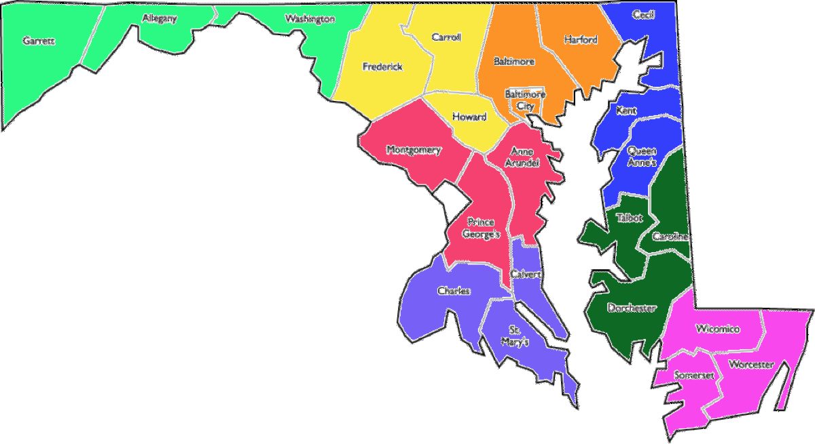

1- Garrett, Allegany, Washington
2- Frederick, Carroll, Howard
3- Baltimore County, Baltimore City, Harford
4- Montgomery, Prince George’s, Anne Arundel
5- Charles, Calvert, St. Mary’s
6- Cecil, Kent, Queen Anne’s
7- Talbot, Caroline, Dorchester
8- Wicomico, Worcester, Somerset

