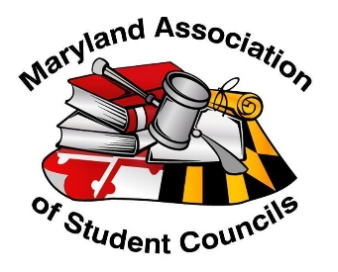
Bid Application Acknowledgement

Spring Leadership Conference (SLC) Host
Saturday, April 13, 2024

I/ we have read the Conference Bid Information document and acknowledge and confirm that we are able to provide and execute the listed responsibilities.

Host advisor name Signature

Host advisor name Signature

Name of school advisor (if not listed above)

School advisor name Signature

The mission of MASC is to foster a statewide environment for all secondary school students to express and exchange opinions and ideas, develop leadership skills, and promote student representation and involvement in all groups and organizations impacting the lives of students.

