Susan Nash Travetto Friend of MASC Award

https://forms.gle/1hCCeMByeFXxYr719

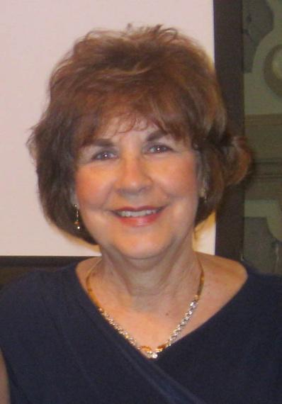
MASC Officers and Executive Director nominate and choose this award recipient. It is given to someone who has contributed to the success and growth of the organization and its leadership team during any given year.
Susan Nash Travetto began her Maryland teaching career as a Physical Education teacher in Charles County. She later worked as a guidance counselor and administrator in Calvert County. She became a Specialist in Research and Development at the Maryland State Department of Education, and then took the position of Student Affairs Specialist. It was in this role that she became the Executive Director of the Maryland Association of Student Councils. Dr. Travetto served more than nine years as the Executive Director, and has the distinction of being the longest serving Executive Director in the history of MASC.
1988 – 1997
Currently, Dr. Travetto is the Coordinator of Teacher Professional Development in the Education Department at McDaniel College, which involves coordinating the field placement office where she helps to provide leadership and support for all school-based internships including student teaching. However, she is always available to support MASC, both its mission and its people.

Dr. Travetto’s philosophy of teaching and leadership is very simple and unoriginal, though greatly inspirational. "No one cares how much you know until they know how much you care." She believes that being a successful leader in any capacity involves attending to relationships! In response, Dr. Travetto carried out her tenure at MASC with the theme that leadership is about finding each individual's strengths and fitting that strength into the mosaic of the organization, which is ultimately what helped MASC to develop into the solid and strong organization that it has become.
In her own words, Dr. Travetto describes her MASC experience: “While I was with MASC, I had the opportunity to work with extraordinary student leaders who sincerely understood that leadership wasn't about being in the spotlight. I will never forget the honor and privilege of serving MASC and working with the most unforgettable student leaders this state has ever known. I learned from them every day, and they helped me to achieve my life goals.”

Dr. Travetto would also like to send a personal message to the MASC student leaders: “Take your positions of leadership very seriously. You have been given a very special opportunity to do the important work in your schools and communities. Never take that for granted because we are all counting on you.”

Dr. Travetto inspired many advisors to be a champion of students and other advisors. She set the tone and modeled how advisors should help others by lifting them up and helping them to succeed. Her willingness to do whatever was necessary for the success of the organization as well as the people involved is what set her apart from others. Many advisors aspire to her standard of excellence, which is what inspired MASC to name this award: The Susan Nash Travetto Friend of MASC Award.

