Name (first and last): ___________________________

MASC Executive Board Meetings (Dec. 9, 2023 and/or May 18, 2024)

PARTICIPANT EMERGENCY INFORMATION FORM
Please complete this form and carry it to the on-site check in (DO NOT MAIL THIS FORM)
School: |  |  |  | Grade: |  |  | Region
*Parent/Guardian: |  | Cell #
Emergency Contact:  (If parents cannot be reached) |  | Cell #
Who is responsible for medical payments? ◻ Individual ◻ Insurance | If individual, please provide credit card information: ◻Visa ◻MasterCard ◻American Express ◻Discover |  |  |  | Name on Credit Card:  Cardholder’s Signature:
School Insurance? Day: ◻ Yes ◻ No  24 Hour ◻ Yes ◻ No | School Insurance:  Company Name: |  |  |  | Policy Number:
Private Medical Insurance?  ◻ Yes ◻ No | Private Medical Insurance  Company Name: |  |  |  | Policy Number: | Physicians Phone Number:
Date of last Immunization Booster: |  |  | ALLERGIES: ◻ Bee Sting ◻ Poison Oak/Ivy ◻ Ragweed ◻ Penicillin ◻ Other (Describe):  Are you allergic to any medication? ◻ No ◻Yes If yes, list:
A licensed health care provider may provide my child with: ◻ Tylenol ◻ Advil ◻ Either ◻ Neither
Special Health Considerations and ANY SPECIAL DIETARY CONSIDERATIONS:
NOTE: Students bringing medications should use the form from their school system. Follow your own school system field trip procedures to transport and “hand off” medications to the MASC executive director or his/her designee. NOTE: If you are taking medication regularly, you must bring a supply in its original labeled container.
Describe any activity in which participant may NOT participate:
*PARENT/GUARDIAN PERMISSION
I, the parent or legal guardian of (my child), authorize the MASC executive director or his/her designee to obtain medical care for my child in the event such care is necessary. I understand that, if possible, I will be contacted in the event my child requires medical attention. I grant to a licensed health care provider or accredited hospital, permission to perform any medical and/or surgical procedures that are essential for the treatment of my child, and agree to be responsible for payment of such care. I release NASSP, its employees, and agents from any damages, liability, or loss resulting from their securing, in good faith, medical care for my child.
*PHOTO PERMISSION (names will NOT be used if requested)
Photographs of the student named above ◻MAY ◻MAY NOT be posted on or used by MASC or other student leadership websites.

Parent/Guardian Signature: Date:
MASC PARTICIPANT CONTRACT
I hereby state that the information provided above is accurate to the best of my knowledge and further agree to participate fully in this Maryland Association of Student Councils event and will comply with the policies and procedures set forth. I further agree to follow all rules and regulations set up by the Maryland Association of Student Councils and my school. Failure to follow these rules or regulations, failure to comply with instructions from advisors or other authorities, or failure to conduct myself in a manner considered to promote a safe and successful experience will result in an immediate removal from the event without refund of charges for my participation.

As leaders, we must be continually aware of our actions and their effects. In order to make an impact we must exercise an awareness of responsibility to ourselves, to the organizations with which we are associated, and to other people. This code was developed through a cooperative process involving the MASC Executive Board, state officers, and regional advisors.

As leaders we will:
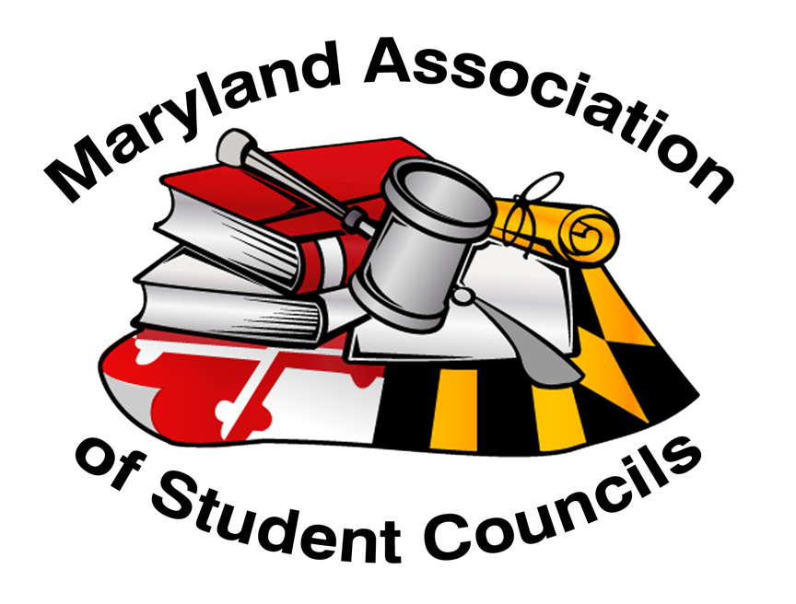
*Serve as role models to our peers and set an example for all to follow.
*Be inclusive of all students while advocating, involvement, and participation in various activities.
*Maintain a high level of respect towards others and ourselves.
*Strive to be committed leaders and encourage others to reach their full potential.
*Remember that part of our leadership responsibilities include helping, training, and encouraging future leaders.
*Fulfill our role as a person whom others can count on and whose word is solid and trustworthy by refraining from cheating, stealing, or lying.
*Realize that our actions directly impact the integrity and credibility of MASC.
*Maintain the high integrity that MASC has achieved.
*Abide by all rules and procedures laid out by our host facility and organization

MASC does not discriminate on the basis of race, color, religion, sex, age, ancestry or national origin, familial status, marital status, physical or mental disability, sexual orientation or genetic information in its programs and activities and provides equal access and a welcoming environment to all groups.
By signing this form, participants in MASC Events, including students and advisors agree to abide by this Code of Ethics and MASC Diversity Statement.
Participant Signature: Date:

Follow MASC on Social Media. Our website is also a great resource- www.mdstudentcouncils.org.
@mdstuco
@md.stuco
https://www.facebook.com/MarylandAssociationofStudentCouncils/

Please bring this completed form to the on-site check-in: DO NOT MAIL THIS FORM

