First Name: Last Name:
ADULT
FORM ONLY

County: School

Eastern Shore Leadership Conference: April 27, 2024

ADVISOR / ADULT EMERGENCY INFORMATION FORM

Emergency Contact: |  |  | Home Phone: |  | Cell Phone
Who is responsible for medical payments? ◻ Individual ◻ Insurance |  | Private Medical Insurance?  ◻ Yes ◻ No |  |  | Private Medical Insurance  Company Name:
Policy Number: |  |  |  | Physicians Phone Number:
Date of last Immunization Booster: | ALLERGIES: ◻ Bee Sting ◻ Poison Oak/Ivy ◻ Ragweed ◻ Penicillin ◻ Other (Describe):  Are you allergic to any medication? ◻ No ◻Yes If yes, list:
Special Dietary Considerations MUST be listed in the registration – Contact Karen.Crawford@mdstudentcouncils.org with any updates/changes
This form will only be used in the case of a medical emergency. Please be sure that all contact information is accurate.
This form will be shredded after this event.
BRIEF MEDICAL HISTORY
(Special Health Conditions – diabetes, seizures, etc.)
Describe any activity in which you can NOT participate:
Authorization
I authorize the MASC executive director or his/her designee to obtain medical care for me in the event such care is necessary. I grant to a licensed health care provider or accredited hospital, permission to perform any medical and/or surgical procedures that are essential for my treatment and agree to be responsible for payment of such care. I release MASC, its employees, and agents from any damages, liability, or loss resulting from their securing, in good faith, medical care for me.

Signature:________________________________________ Date:______________________
ADVISOR CONTRACT
I hereby state that the information provided above is accurate to the best of my knowledge and further agree to participate fully in this Maryland Association of Student Councils event and will comply with the policies and procedures set forth. I further agree to follow all rules and regulations set up by the Maryland Association of Student Councils and my school.

As adult role models, we must be continually aware of our actions and their effects. In order to make an impact we must exercise an awareness of responsibility to ourselves and to the organizations with which we are associated.
- Advisors are responsible for the behavior and attire of their students at all times.
- Please keep devices in silent mode to avoid disruption. Devices are encouraged for on-task and conference-relevant engagement. Advisors should remind students to refrain from off-task activities on personal devices during conference sessions.
- Advisors should attend all the general sessions, workshops, or events to supervise student delegates, making certain their students are on time and attending all sessions. Advisors are to sit with/near their respective delegation during general sessions to supervise them.
- Advisors must review responsibilities and expectations outlined on the Student Emergency Form with their student delegates to clearly define expected behavior prior to attending.

MASC does not discriminate on the basis of race, color, religion, sex, age, ancestry or national origin, familial status, marital status, physical or mental disability, sexual orientation or genetic information in its programs and activities and provides equal access and a welcoming environment to all groups.

By signing this form, I agree to abide by these guidelines and MASC’s Diversity Statement.

Advisor Signature:____________________________________________ Date:_______________________
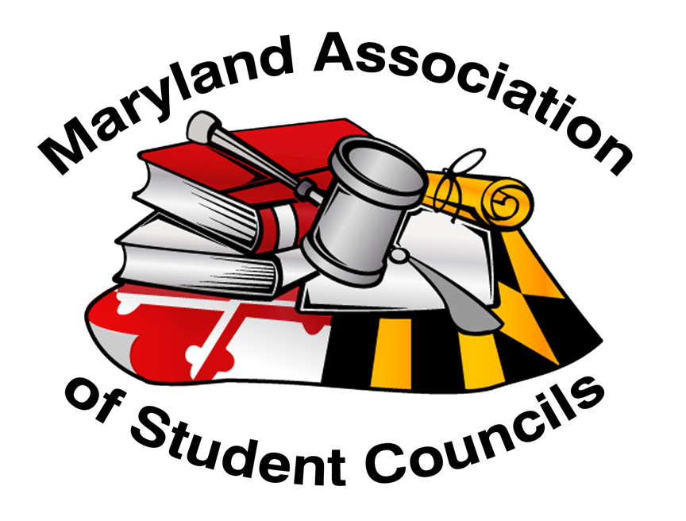

Please bring this completed adult form to the on-site check-in.

