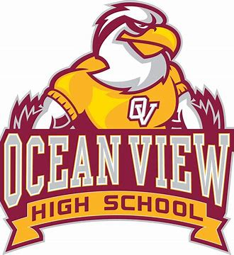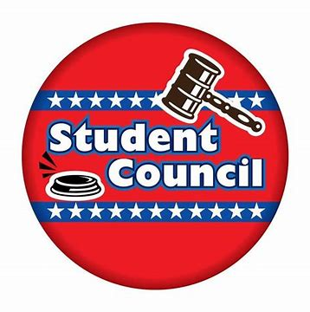Ocean View High School Student Council  
2100 Main Street  
Ocean City, Maryland, 20904  
https://mdstudentcouncils.org/

Date

Dear [name of person/organization]

My name is Karen Crawford and I am a student leader in the Ocean View High School Student Council. I am interested in attending the National Association of Student Councils (NASC) LEAD Conference to help me in my efforts to become a better student leader. *(NASC is sponsored by the National Association of Secondary School Principals – NASSP).*

### The LEAD Conference is being held this year in Washington, D.C, February 27–March 1, 2026. It will bring together students and advisors for several days of immersive learning from nationally acclaimed speakers, tailored leadership training, and diverse peer-to-peer connections. It will help me with the tools I need to strengthen my leadership, grow my school’s council, and develop lifelong skills to drive my professional journey.

In order to go to the National Student Council Conference, I need to raise $       to help pay for my registration and hotel. I have saved $       and am in need of assistance to attain the remainder of the expenses. **The deadline for me to submit my conference registration is _**  . I hope that you will consider my request and be able to provide assistance with costs. Even $10 – $20 dollars helps!

If you are available, I would like to meet with you in the near future to discuss my request. I can call or visit you at [time and date]. Should you need to contact me before then, I can be reached at [phone number or email].

I am looking forward to speaking or meeting with you.

Respectfully,

[Your signature!]

*PS. I am attending this conference with a delegation of students and advisors from the Maryland Association of Student Councils (MASC). MASC is a 501(c)3 non-profit organization. Their Maryland state tax exempt number is #31210972.*

Ocean View High School Student Council  
2100 Main Street  
Ocean City, Maryland, 20904  
https://mdstudentcouncils.org/

Date

Dear________________,

Thank you for your [your organization's] contribution of $       to help me attend the National Association of Student Councils LEAD Conference that is being held in Washington, D.C, February 27–March 1, 2026.

I am looking forward to using my conference experience to help me in my current leadership position and to improve my abilities to serve others. After my return, I will share my experience with you. I will also be glad to talk about my experiences in a presentation to your organization. Thank you again for your contribution and for making it possible for me to have this valuable learning opportunity.

Sincerely,

[Your signature]

*Suggestion - Do a nice hand written card…*